

**University: United States International-Africa**

**Faculty: School of Science and Technology**

**Project Title: Currency Trader Performance Analysis System**

**Major: Applied Computer Technology**

**Apt 3065 B: Mid Term Project**

**Student Name: Tapiwa Civil Chimbwanda 662676**

**A research project submitted in partial fulfillment of the requirement for the award of the undergraduate degree in Applied Computer Technology (APT)**

**FALL 2023**

**Certification**

**This is to certify that this project entitled Currency Trader Performance Analysis System presented by Tapiwa Chimbwanda 662676 meets the project requirements and regulations governing the award of a Bachelor of Science (B.Sc.) degree in Applied Computer Technology at USIU-Africa.**

**I, Tapiwa Chimbwanda with student number 662676 hereby declare that this project Currency Trader Performance Analysis System is a project for my efforts that have not been presented before by any researcher or for any other academic purposes and it is the result of my personal research efforts. All borrowed ideas have been acknowledged in the reference.**

**Sign: ………………………………… Date: …………………………….**

**Tapiwa Chimbwanda (Student)**

**The above declaration is confirmed by**

**Sign: …………………………………… Date: …………………………….**

**MR. CHRISPUS AKHONYA (Instructor)**

**Declaration**

**This research project, as presented in this report, is my original work and has not been presented in any other university for a degree award.**

**Student …………………………………………………………………………**

**Signature……………………………………………………………………**

**Date……………………………………………………………………………**

**This research project has been submitted in partial fulfillment of the requirement of the award of the undergraduate degree in Applied Computer Technology of USIU-Africa with my approval as the university supervisor.**

**Supervisor………………………………………………………………………**

**Signature……………………………………………………………………….**

**Date……………………………………………………………………………**

**Github url**

**Acknowledgement**

**I extend my deepest appreciation to my professor, Mr Chrispus Akhonya, CEH for being an inspiring instructor and for fostering an enriching learning experience. Their support has been invaluable, and I am truly fortunate to have had the opportunity to learn under their guidance.**

**Abstract**

The problem is that retail forex traders lack a performance analysis system that journals their trading history and has metrics in place to systematically track their progress across time to measure growth, returns assessment, risk analysis and trading strategies evaluation so as to have a portfolio that showcase their strategies and trading experience graphically to potential investors to seek for capital and funding

The main objective is to build a system that analyses trader’s performance and keeps a record of their experience and activities in the financial markets. This was achieved by implementing the following specific objectives first to build a system that has metrics and financial analytics that determines whether a trader is profitable or not and if not are they progressively improving. To develop a system that performs reporting and visualization by presenting performance data in a clear and understandable graphical interface that is customizable and interactive which the trader can present as a prototype of their strategy and results to any investor or interested party. To deploy a system that has trade history and activity logging in a data database schema for trade records, including entry/exit prices and volumes

I used a MERN stack that is Mongo DB, Express, React and Node. The main language used was TypeScript accompanied with **HTML**, **CSS** and other graph related APIs like ApexCharts and yahoo finance. Mongo was the database I used to store the data and login credentials. React was for front-end development. Express and Node were for my server.

Table of Contents

1 **CHAPTER ONE:** 4

**1.1** **Introduction** 4

**1.2** **Background Of the Study** 4

**1.3** **Problem Statement** 5

**1.4** **Objectives** 5

**1.4.1** **General Objective** 5

**1.4.2** **Specific Objectives** 5

**1.5** **Research Questions** 5

**1.6** **Significance of the Study** 6

**1.7** **Scope and Limitation of the Study** 6

**2** **CHAPTER TWO: Literature Review** 7

**2.1** **Introduction** 7

**2.2** **Review of objective one :** 7

**2.3** **Review of objective two:** 8

**2.4** **Review of objective three:** 8

**2.5** **Review of objective four:** 9

**2.6** **Concept map** 9

**3** **Chapter 3: Methodology** 10

**3.1** **Research methodology/Research design used** 10

**3.2** **Data collection methods used.** 11

**3.2.1** **Optional Diagrams** 15

**3.3** **Research Ethics** 16

**4** **Chapter 4: System Implementation and Deployment** 17

**4.1** **Introduction** 17

**4.2** **System architecture** 17

**4.3** **Front end development** 17

**4.4** **User interface Design** 17

**4.5** **Back- end development** 17

**4.5.1** **Database Design models** 17

**4.5.2** **Tables (if any) or data models CSV file Artff etc.** 17

**4.5.3** **Code testing** 17

5 **References** 18

**Table of Figures**

Figure 2.1 Concept Map 6

Figure 3.1 Context Diagram 9

Figure 3.2 Level 1DFD 10

Figure 3.3 Use Case 11

# **CHAPTER ONE:**

## **Introduction**

This project is in the area where finance meets technology (computer science) known as Fin-tech. This is where the financial markets are integrated with computer science mostly through algorithms and applications that makes financial markets participants in form of brokers, banks, financial institutions, retail traders and prop firms to extract more return on investments (money) from the markets through access to automation and the speed that comes with computational power.

The problem is that this space has recently been made accessible to retail traders thanks to cheap access to personal computers and software that gives them access to real time up to date financial information.

To do justice to this project and fully expose the current situation retail traders are in, other topics of interest come to play because they have influenced the situation in one way or another these include fin-tech, market players (participants)and their influence and the rules and regulations and how they have influenced the situation

## **Background Of the Study**

There was a change in regulations in the late 90s to early 2000s some of which were the allowance of anyone to participate in foreign markets and removal of the $10 000 base fee required for people to participate in the financial markets (Iwona Sobol, 2020). This led to the significant growth of a group of participants known as retail investors or retail traders who contributed $753.2 Billion. Of all the retail investors 20% actually believe that retail traders cannot make money and of the remaining 80% only 30% are actually profitable according to a report by the IMARC Group (IMARC Group, 2022).

The above statistics show that majority of retail traders do not know exactly what they are doing meaning most are treating it as a hobby whilst their counterparts are treating it as a business. Therefore, the institutions have systems and software in place to make sure that they have a net positive return on investments. The issue now is that this software is privately owned by those institutions and are inaccessible to the retail traders.

Ultimately, retail traders lack software and systems to function like a business and to be able to present their experience professionally enough to engage with other interested professional parties like investors and banks to acquire funding.

## **Problem Statement**

Retail traders are way behind and disadvantaged compared to their market competitors mentioned above because they lack software that has metrics in place to systematically track their progress across time to measure growth, returns assessment, risk analysis and trading strategies evaluation which has ultimately made it impossible for them to have a portfolio that proves their trading experience, which they can present to investors

## **Objectives**

### **General Objective**

To build a system that analyses trader’s performance and keeps a record of their experience and activities in the financial markets.

### **Specific Objectives**

1. To build a system that has metrics and financial analytics that determines whether a trader is profitable or not and if not, are they progressively improving
2. To develop a system that performs reporting and visualization by presenting performance data in a clear and understandable graphical interface that is customizable and interactive which the trader can present as a prototype of their strategy and results to any investor or interested party
3. To deploy a system that has trade history and activity logging in a data database schema for trade records, including entry/exit prices and volumes
4. To design a system that has user authentication and profile management system for traders to access their accounts and manage their profiles.

## **Research Questions**

1. What are the key metrics and indicators that accurately determine a trader's profitability?
2. How can visualization techniques effectively convey the trader's strategy and results to potential investors or interested parties?
3. What mechanisms can be implemented to ensure data integrity and accuracy in the trade history database?
4. What measures should be taken to safeguard user data and privacy within the system?

## **Significance of the Study**

The successful completion of this project signifies potential connections with diverse domains such as machine learning proficient trading strategies can seamlessly transition into automated systems. This same system can be used to evaluate that algorithms performance given different market conditions. Another advantage is that performance analysis is not only limited to retail traders but also institutions, small hedge funds and quantitative trading systems

## **Scope and Limitation of the Study**

The scope of this project is to assess the trading activity within the markets without delving into the specific details of the trader's strategy, or even the presence of one. It focuses solely on evaluating the overall net impact of the trader's actions over time, determining whether it demonstrates a positive or negative outcome. This analysis aims to ascertain if the activities undertaken are conducive enough for potential investors to consider allocating capital.

# **CHAPTER TWO: Literature Review**

## **Introduction**

**Topic Sentence**

Creating a ground-breaking platform to empower retail traders to change the way they navigate the financial markets in an industry where 90% of individuals experience a staggering 90% loss within just 90 days, the system aims to provide traders with insights and tools to not only track their progress but also establish a competitive edge (IMARC Group, 2022).

This project aimed to evaluate trading activity in markets without examining specific strategies or their existence. It focused on assessing the overall impact of the trader's actions to determine if it demonstrated a positive or negative outcome. The goal was to determine if these activities were favourable for potential investors considering capital allocation.

## **Review of objective one :**

**To build a system that has metrics and financial analytics that determines whether a trader is profitable or not and if not are they progressively improving.**

Retail investors are individual investors who trade in relatively small quantities of capital, as opposed to institutional investors who have millions if not billions in assets under management. This objective is particularly relevant to them as they often lack the resources and expertise of institutional investors and may benefit greatly from automated tools to assess their performance.

Existing literature acknowledges the importance of metrics and analytics in trading. Metrics such as Sharpe ratio, maximum drawdown, win rate, and others are commonly used to evaluate trading performance. However, the retail investors lack access to these sophisticated systems and metrics for example according to Bank of International Settlements recent crypto trading activities showed increased losses for retail traders as a result of sophisticated investors selling and smaller retail investors buying (Giulio Cornelli, 2023).

The idea of monitoring progressive improvement in trading is supported by literature. Many successful traders emphasize the importance of continuous learning and adapting strategies over time mainly because there are many changing components from an economic and political perspective like interest rates and wars that affect the markets in an unpredictable manner. Therefore, there is need to monitor change to adapt accordingly and with that comes the need to progressively monitor improvement in new environments

## **Review of objective two:**

**To build a system that performs reporting and visualization by presenting performance data in a clear and understandable graphical interface that is customizable and interactive which the trader can present as a prototype of their strategy and results to any investor or interested party**

Studies highlight the significance of clear and intuitive visualization for retail investors who may not have the same level of expertise as institutional investors. Visual representations can help them make informed decisions and understand the performance of their investments on a macro scale since they are mostly focused on the current positions and daily activities. It makes it hard to make and keep a long-term mental map of their performance.

Enabling retail traders to present their strategies and results to potential investors addresses a key aspect of seeking external funding or partnerships. Literature on start-up pitching and investment presentations emphasizes the need for clear, compelling visualizations across all business as it is a good form of communication (Iwona Sobol, 2020).

Empowering retail investors with tools for reporting and visualization aligns with the trend of democratizing access to financial information and trading technology. It emphasized that the importance of providing retail investors with user-friendly tools and platforms is crucial for success.

## **Review of objective three:**

**To build a system that has trade history and activity logging in a data database schema for trade records, including entry/exit prices and volumes**

Maintaining a comprehensive trade history with detailed activity logging is considered a fundamental practice in trading. It allows traders to review and analyse their past trades, which is crucial for learning from successes and mistakes and tweaking strategies in relation to current market conditions, which are always changing.

Retail investors, especially those who manage their own portfolios, benefit greatly from robust record-keeping systems. Importance in personal finance and investment management emphasizes the need for accurate and detailed trade records if growth is to be realized

Literature highlights the significance of effective risk management in trading. It allows traders to assess their risk exposure, track position sizes, and make adjustments to their strategies as needed.

## **Review of objective four:**

**To build a system that has user authentication and profile management system for traders to access their accounts and manage their profiles.**

User authentication is a critical security measure in any digital platform, particularly in financial services. The importance of robust authentication mechanisms to protect user accounts from unauthorized access is key part to ensure data integrity.

Allowing traders to manage their profiles is a standard feature in modern financial platforms. This enables users to update personal information, set preferences, and customize their experience. The significance of user-centric interfaces for enhancing engagement

## **Concept map**

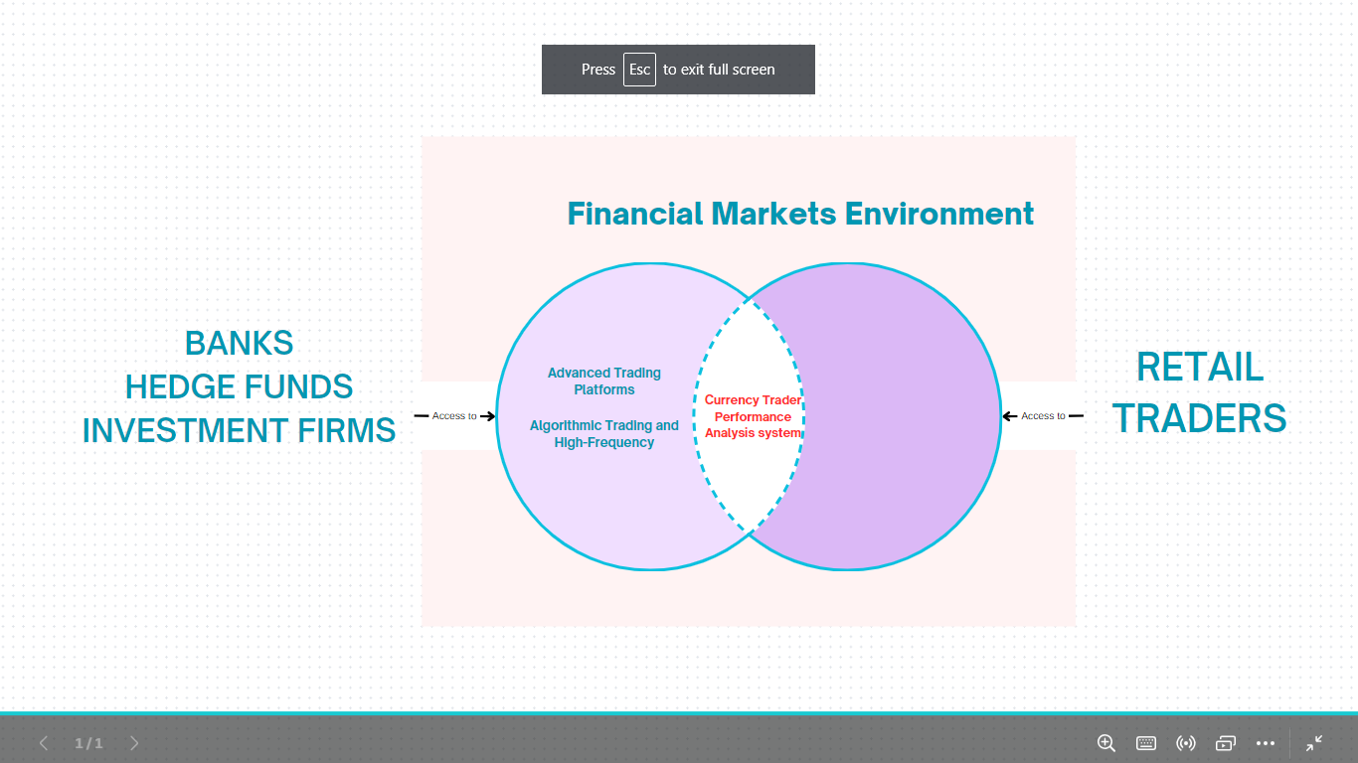

Figure 2.1 Concept Map

The above diagram shows the imbalance in resource access between institutions and retail traders participating in the financial markets as a result of monopolization and privatization of resources which created a gap in the middle which I addressed with the system I built so as to give retail traders an edge in the markets

# **Chapter 3: Methodology**

## **Research methodology/Research design used**

A mixed-method approach was used that is both **Quantitative and Qualitative research** were used as research methods to this project.

The reason for this approach for this approach was to provide a more comprehensive understanding of currency trader performance where quantitative data on trading metrics like statistics can be complemented by qualitative insights from case studies to create a more holistic view.

For qualitative approach a case study approach was used involving an in-depth examination of more currency traders through the use of reports generated and published by interested parties. This method is enabled for gaining an understanding of individual traders' experiences, decision-making processes, and the contextual factors that influence their performance as concluded in those report findings (IMARC Group, 2022).

To add on, some observations were made from **Interviews and Forex Summits Discussions** found on YouTube and paid courses. Through these interviews of traders and focus group discussions insights into traders' perceptions, motivations, and strategies were captured through quantitative measures.

For the quantitative approach an experimental design methodology was used where I manipulated variables (e.g., trading strategies, risk levels) and observe the impact on my trading performance over a long period of and recorded the results and effects of the changes made

## **Data collection methods used.**

Data was collected from brokerage firms as reports of the accounts that were opened and traded with them. Trader Transaction Logs also provided detailed transaction logs for each trader, including buy/sell decisions, entry and exit points, trade sizes, and profit/loss outcomes.**Design Diagrams**

1. **Context Diagram**

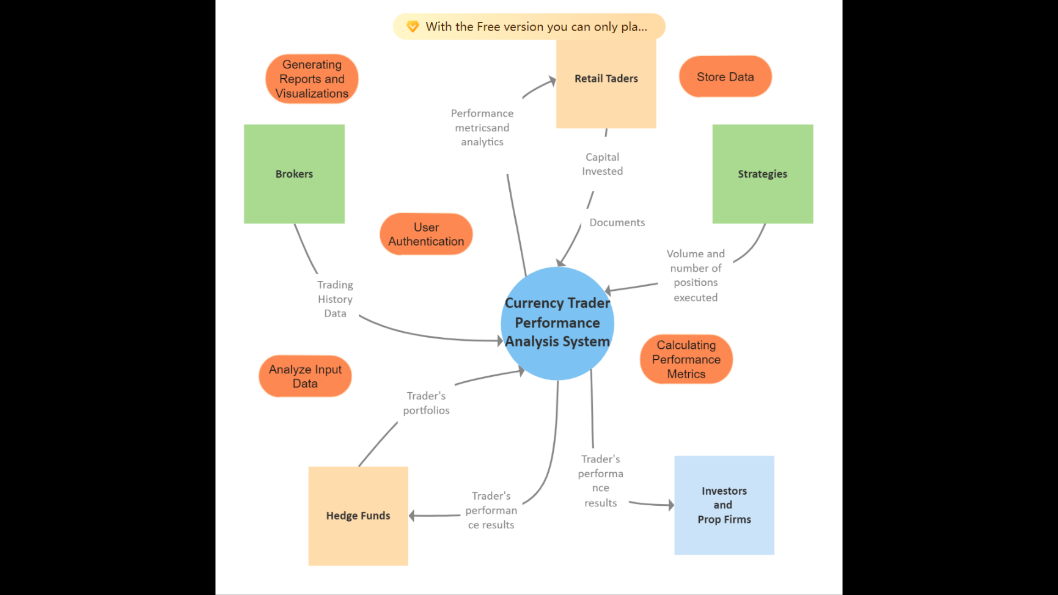

Figure 3.1 Context Diagram

1. **Level 1 DFD**

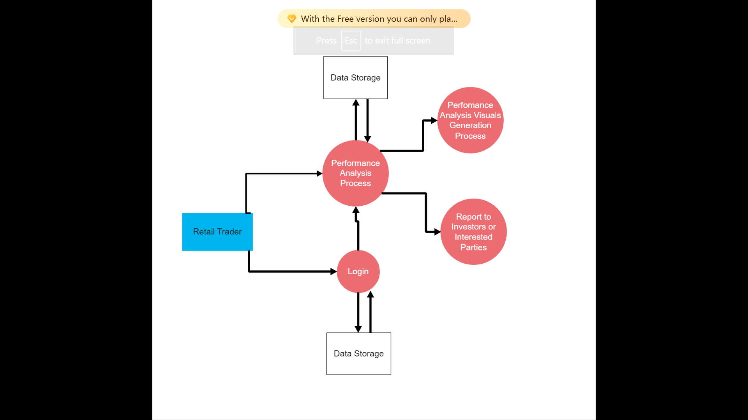

Figure 3.2 Level 1DFD

1. **Use Case Diagram**

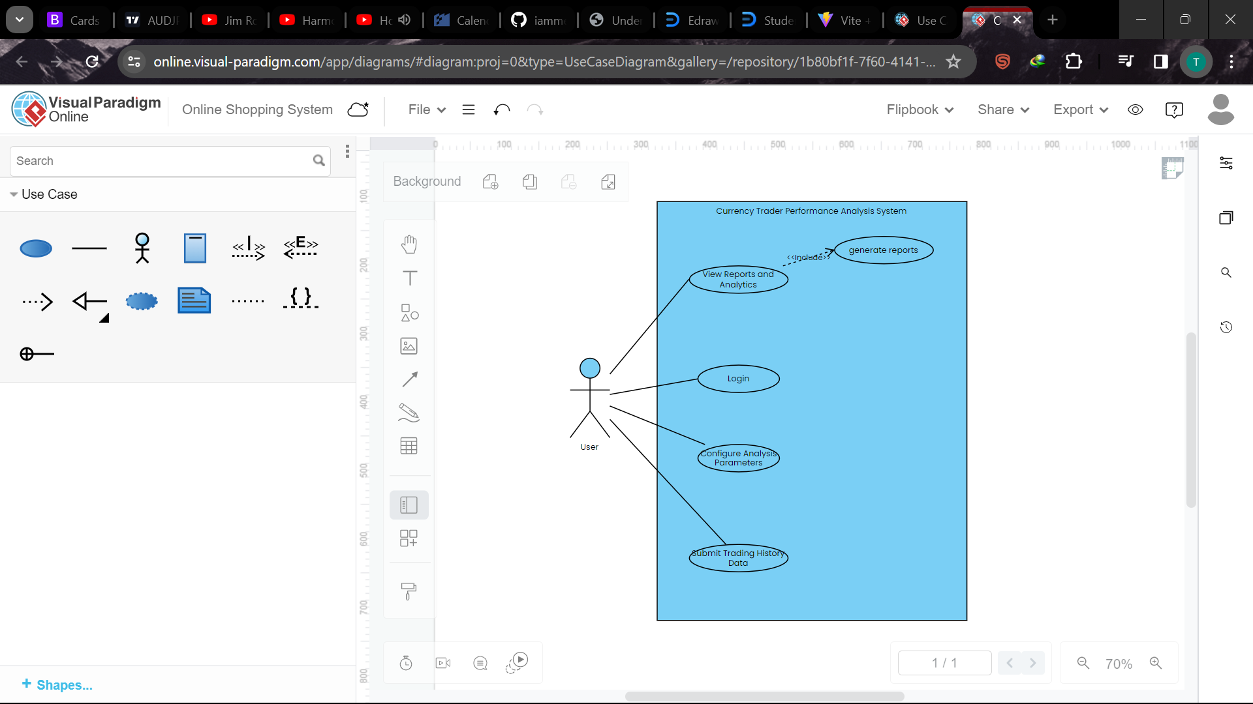

Figure 3.3 Use Case

## **Research Ethics**

I ensured confidentiality and data security by implementing user authentication which therefore means only personnel with authorized access that is the user and the system admin can view and manipulate the data. I used Mongo DB (database) for data storage which offer their own separate authentication meaning the data is even more protected and inaccessible to third parties

# **Chapter 4: System Implementation and Deployment**

## **Introduction**

**React**, a powerful JavaScript library, served as the foundation for the project's frontend, facilitating the creation of interactive and responsive user interfaces.

Bootstrap, a popular CSS framework, was utilized to ensure a consistent and visually appealing design across different devices and screen sizes. The integration of **ApexCharts** brought dynamic and visually engaging data visualizations to the project, enhancing the presentation of complex information.

The styling and layout were further refined using **CSS**, allowing for customization and a polished aesthetic. To handle the project's backend, **MongoDB**, a NoSQL database, and **Mongoose**, an ODM (Object Data Modelling) library for MongoDB and **Node.js**, were employed. These technologies provided a scalable and efficient data storage solution, allowing the project to manage and retrieve information seamlessly.

**Express and Node.js** formed the backend infrastructure, offering a robust and scalable server environment. **Axios**, a promise-based HTTP client, facilitated smooth communication between the frontend and backend, ensuring efficient data transfer and seamless interactions.

The combination of these technologies resulted in a successful project that not only met but exceeded expectations, providing a user-friendly interface, visually appealing design, and reliable data management.

## **System architecture**

## **Front end development**

1. **Bootstrap for Responsive Design:**

Bootstrap serves as the foundation for the project, providing a responsive and mobile-friendly layout. It ensures a consistent and visually appealing user interface across various devices and screen sizes. The grid system and pre-designed components offered by Bootstrap expedited the development process, allowing creation of a professional-looking interface

Responsive Components: Leveraging Bootstrap's built-in components, such as navigation bars, modals, and forms, streamlines the development of a user-friendly interface. These components are optimized for responsiveness, ensuring a seamless experience for traders.

1. **React for Interactive UI:**

React, a JavaScript library for building user interfaces, creates a dynamic and interactive front-end. Its component-based architecture enabled the modular construction of complex UI elements, enhancing code maintainability and reusability. Component-Based Structure: The UI is broken down into reusable components, each responsible for a specific functionality or display element. This modular approach simplifies development, debugging, and updates.

1. **ApexCharts for Data Visualization:**

ApexCharts, a JavaScript charting library based on ApexCharts.js, is integrated to provide visually compelling and insightful representations of the retail trader's performance data. Customizable Charts: ApexCharts offers a wide range of customizable charts, including horizontal bar charts and graph charts. This flexibility enables developers to tailor the visualizations to the specific needs of the performance analysis system.

1. **CSS for Styling:**

Cascading Style Sheets (CSS) were utilized to enhance the aesthetic appeal and branding of the performance system. Brand Consistency: CSS was employed to maintain a consistent visual identity throughout the application, including colour schemes, typography, and spacing. This consistency reinforces the brand and improves user recognition.

## **User interface Design**

Figure 4.1 User Dashboard

## 

Figure 4.2 User Data

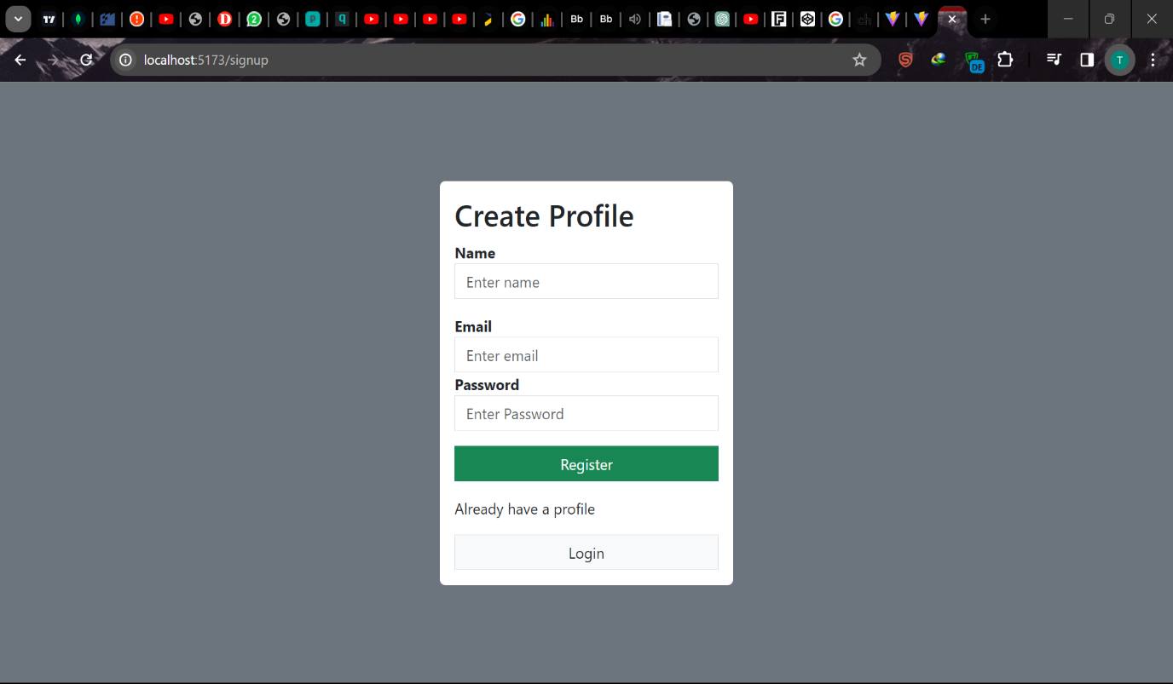 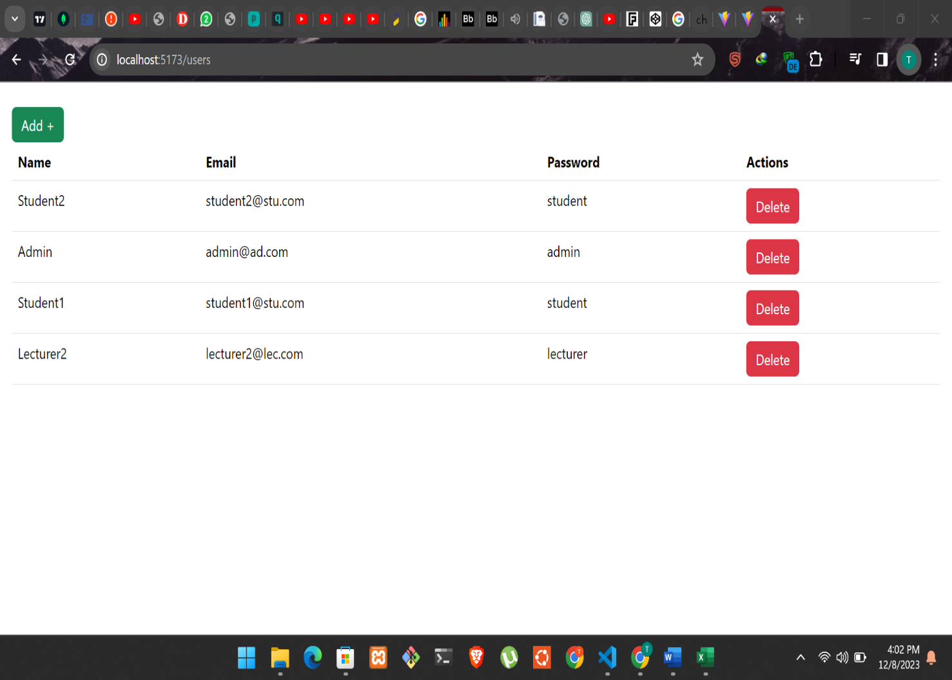

Figure 4.3 Sign-Up Page

Figure 4.4 Admin Dashboard

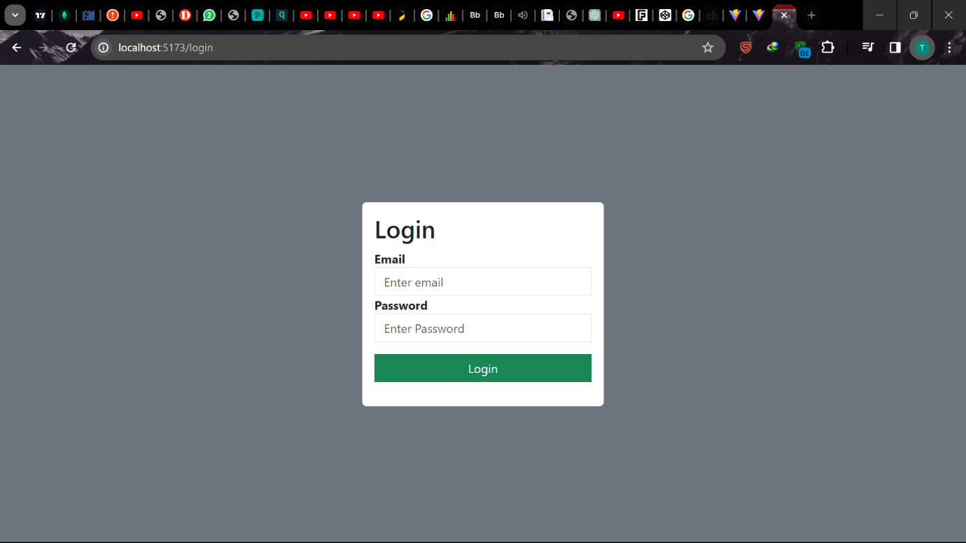

Figure 4.5 Log In Page

## **Back- end development**

To handle the project's backend, **MongoDB**, a NoSQL database, and **Mongoose**, an ODM (Object Data Modelling) library for MongoDB and **Node.js**, were employed. These technologies provided a scalable and efficient data storage solution, allowing the project to manage and retrieve information seamlessly.

**Express and Node.js** formed the backend infrastructure, offering a robust and scalable server environment. **Axios**, a promise-based HTTP client, facilitated smooth communication between the frontend and backend, ensuring efficient data transfer and seamless interactions.

The combination of these technologies resulted in a successful project that not only met but exceeded expectations, providing a user-friendly interface, visually appealing design, and reliable data management.

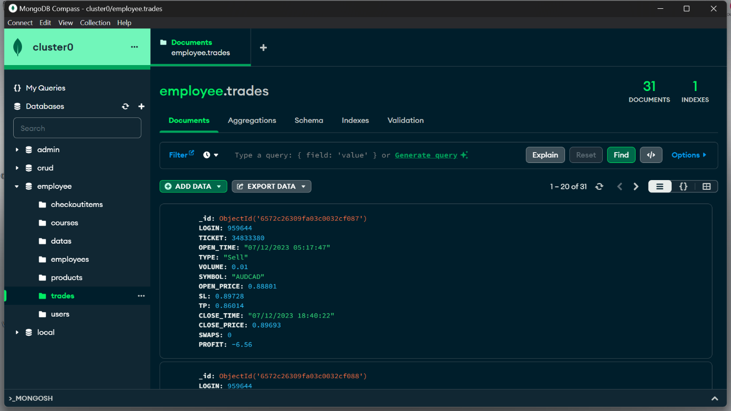

Figure 4.6 Database User-Data

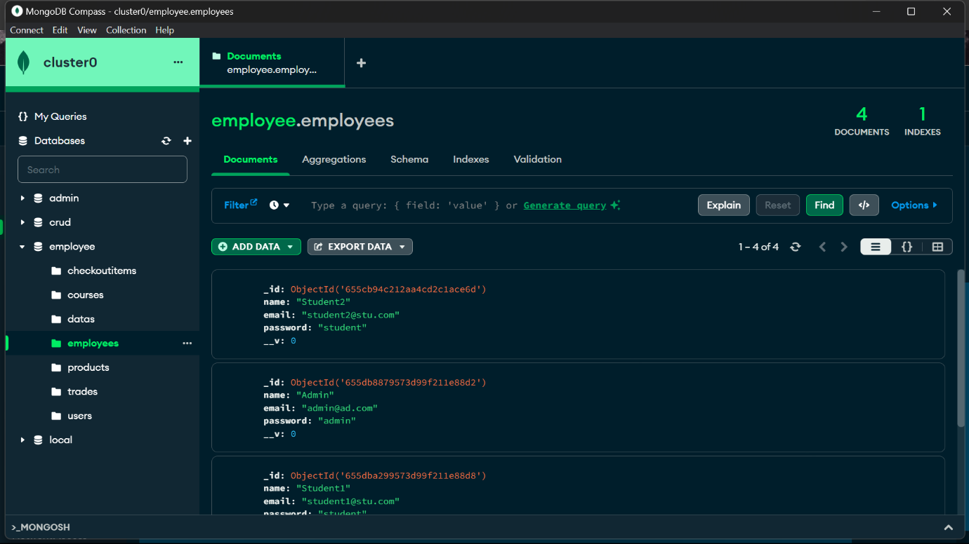

Figure 4.7 Database Users

### **Database Design models**

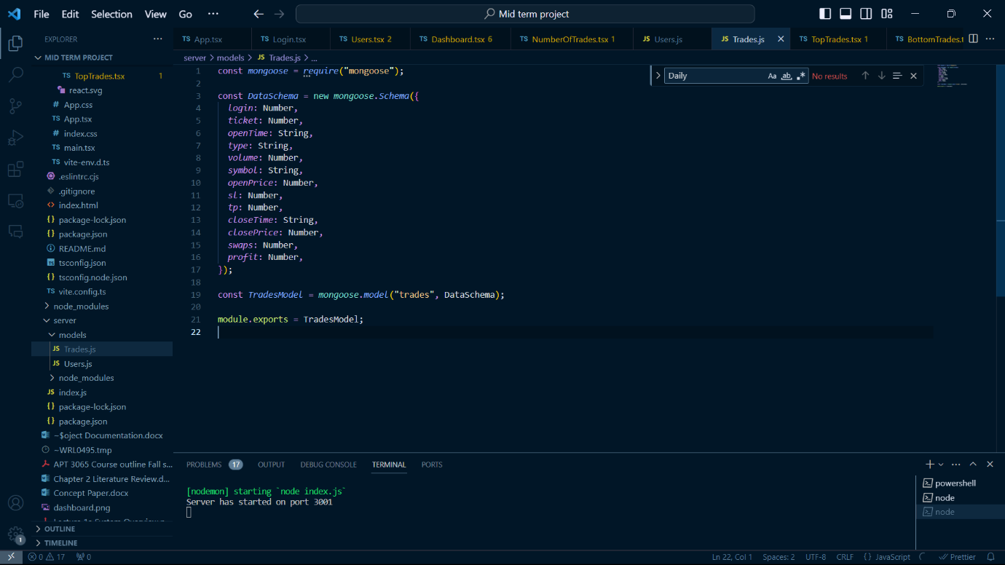

Figure 4.8 Database Schema - User Data

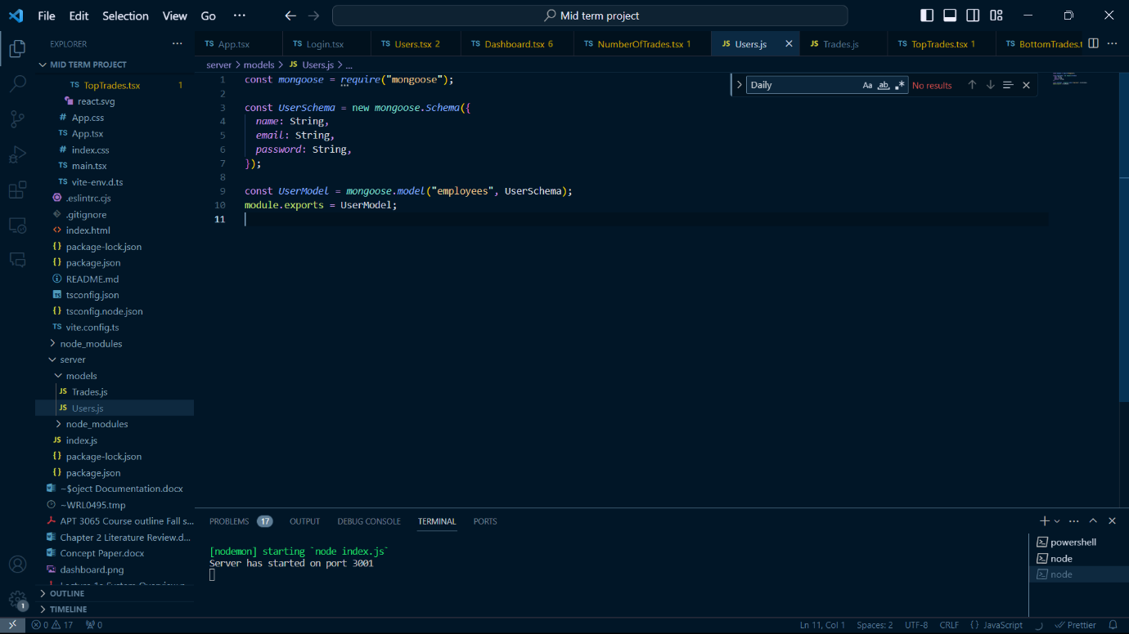

Figure 4.9 Database Schema - Users

# **Chapter 5: Appendices**

# **References**

Giulio Cornelli, S. D. (2023). Crypto shocks and retail losses. *BIS Bulletin*.

IMARC Group. (2022). *Foreign Exchange Market: Global Industry Trends, Share, Size, Growth, Opportunity and Forecast 2023-2028.* IMARC Group.

Iwona Sobol, M. S. (2020). Retail investors in the foreign exchange market. *RESEARCH PAPERS OF WROCLAW UNIVERSITY OF ECONOMICS AND BUSINESS*.